STEGANOGRAPHY

Aim:

To detect and analyze possible hidden data (steganography) in image files using Autopsy.

**DESCRIPTION OF THE TOOL USED:**

Steganography involves hiding information inside digital media like images or audio files. In this experiment, hidden data was detected and analyzed using Autopsy. The tool helps identify unusual metadata, file signatures, and embedded content. Autopsy, combined with steganalysis tools, can reveal hidden messages or malicious payloads. The experiment highlights the role of forensics in uncovering concealed digital evidence. It demonstrates the ability to detect steganographic manipulation in multimedia files

**STEPS INVOLVED:**

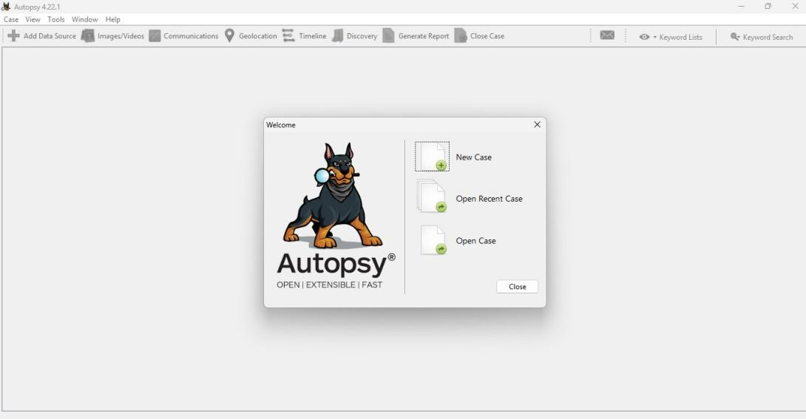

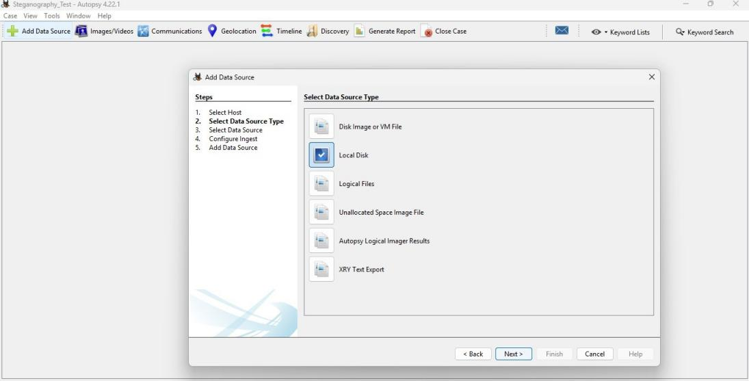

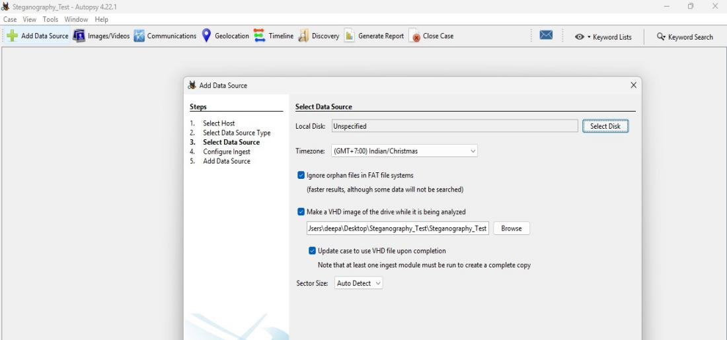

**OUTPUT:**

